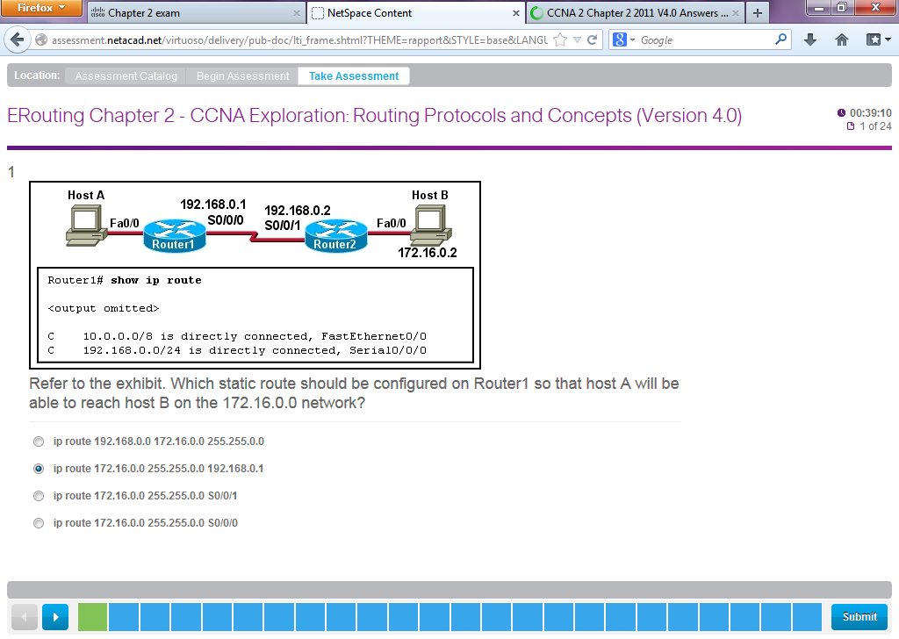

**18**.

[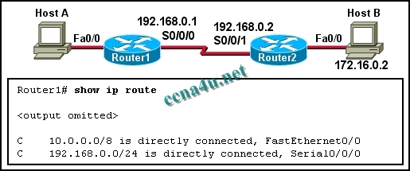](http://answers.ccna4u.net/wp-content/uploads/2011/02/063.jpg)

**Refer to the exhibit. Which static route should be configured on Router1 so that host A will be able to reach host B on the 172.16.0.0 network?**  
**ip route 192.168.0.0 172.16.0.0 255.255.0.0**  
**ip route 172.16.0.0 255.255.0.0 192.168.0.1**  
**ip route 172.16.0.0 255.255.0.0 S0/0/1**  
**ip route 172.16.0.0 255.255.0.0 S0/0/0**

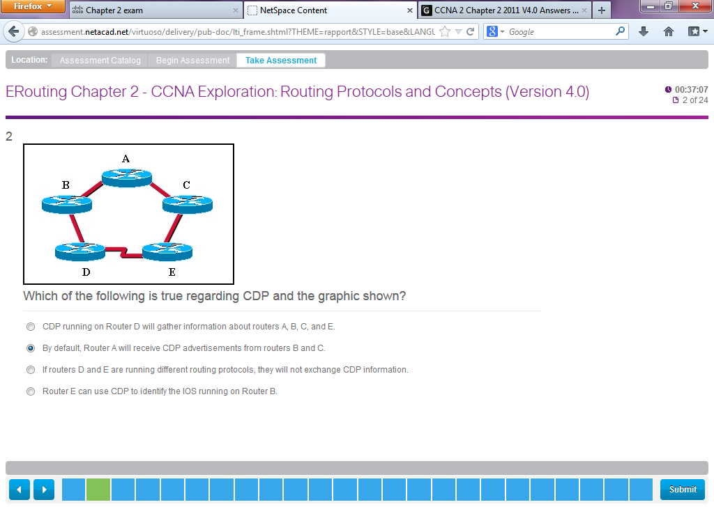

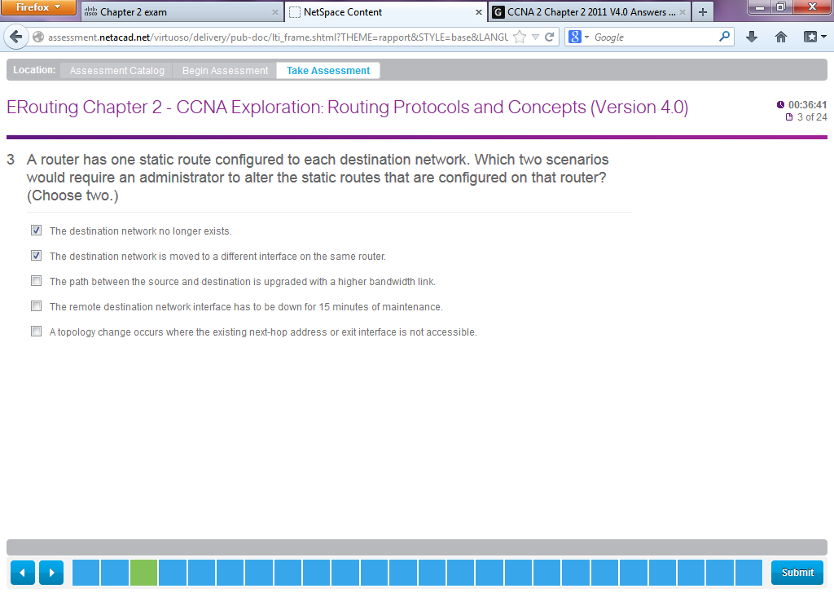

**15**. **A router has one static route to each destination network. Which two scenarios would require an administrator to alter the static routes that are configured on that router? (Choose two**.)  
The destination network no longer exists.  
The destination network is moved to a different interface on the same router.  
The path between the source and destination is upgraded with a higher bandwidth link.  
A topology change occurs where the existing next-hop address or exit interface is not accessible.  
The remote destination network interface has to be down for 15 minutes of maintenance.

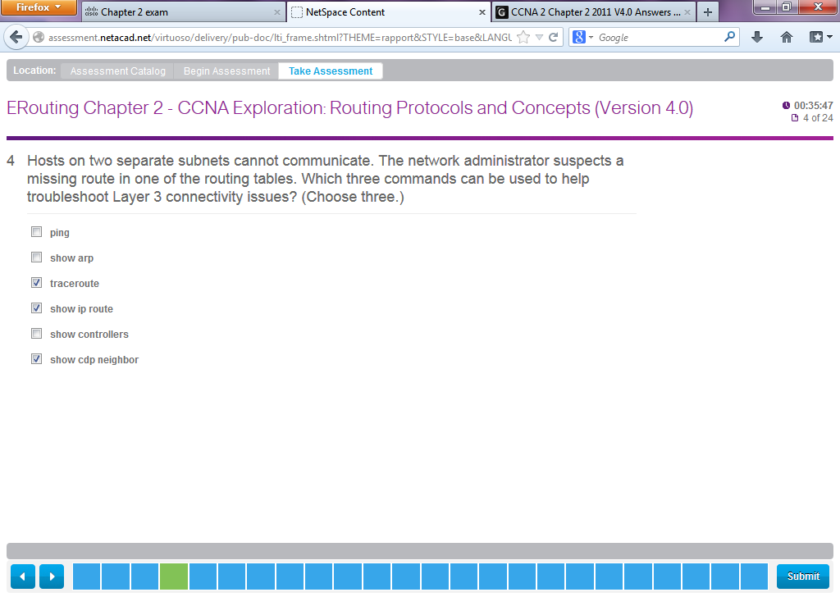

**9**. **Hosts on two separate subnets cannot communicate. The network administrator suspects a missing route in one of the routing tables. Which three commands can be used to help troubleshoot Layer 3 connectivity issues? (Choose three.)**  
ping  
show arp  
traceroute  
show ip route  
show interface  
show cdp neighbor detail

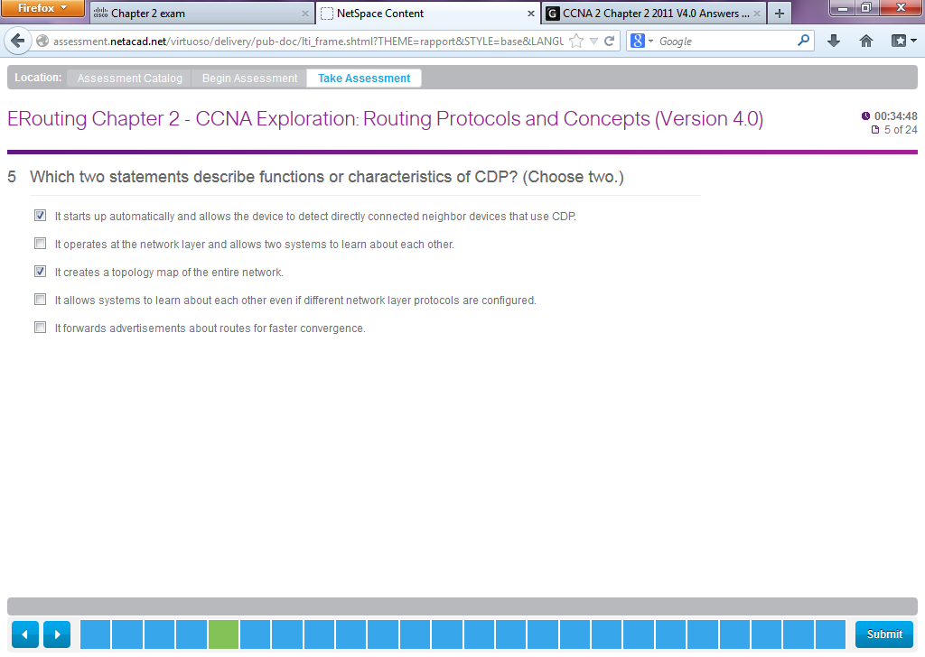

**21**. **Which two statements describe functions or characteristics of CDP? (Choose two.)**  
It starts up automatically and allows the device to detect directly connected neighbor devices that use CDP.  
It operates at the network layer and allows two systems to learn about each other.  
It creates a topology map of the entire network.  
It allows systems to learn about each other even if different network layer protocols are configured.  
It forwards advertisements about routes for faster convergence.

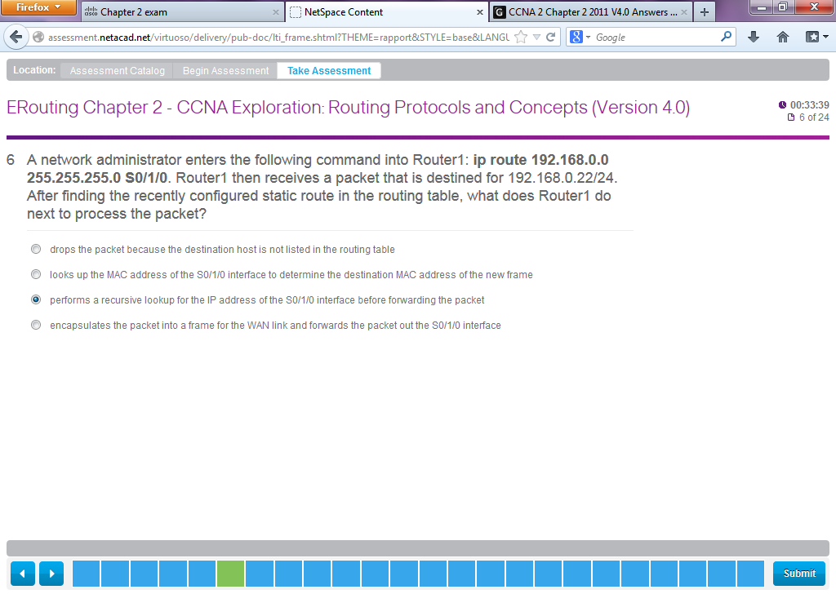

**6**. **A network administrator enters the following command into Router1: ip route 192.168.0.0 255.255.255.0 S0/1/0. Router1 then receives a packet that is destined for 192.168.0.22/24. After finding the recently configured static route in the routing table, what does Router1 do next to process the packet?**  
drops the packet because the destination host is not listed in the routing table  
looks up the MAC address of the S0/1/0 interface to determine the destination MAC address of the new frame  
performs a recursive lookup for the IP address of the S0/1/0 interface before forwarding the packet  
encapsulates the packet into a frame for the WAN link and forwards the packet out the S0/1/0 interface

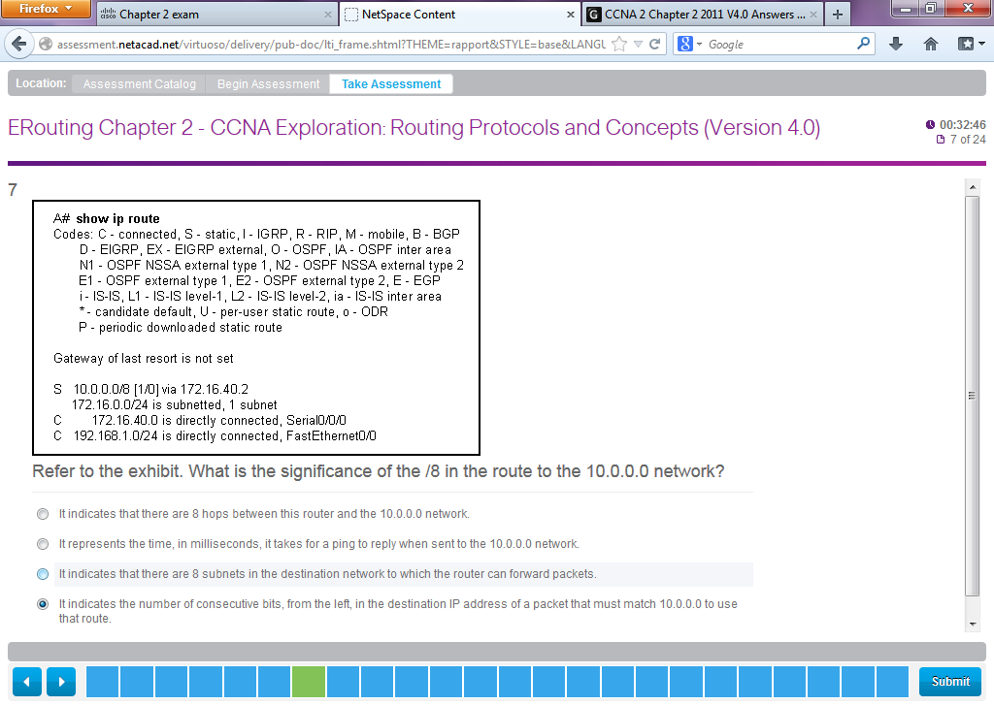

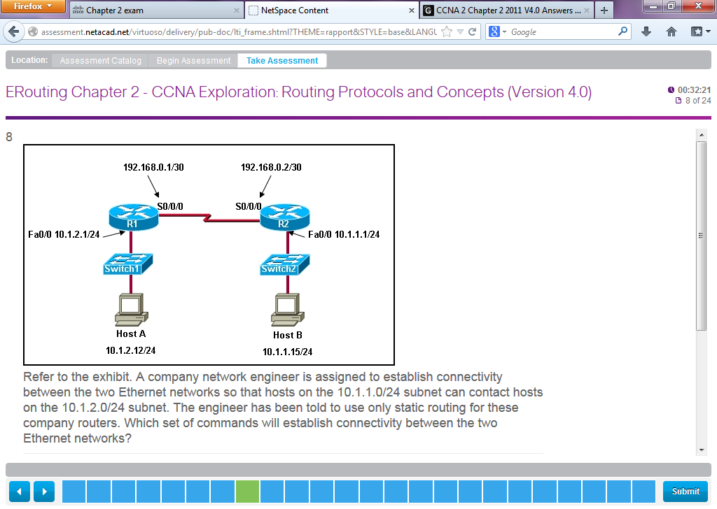

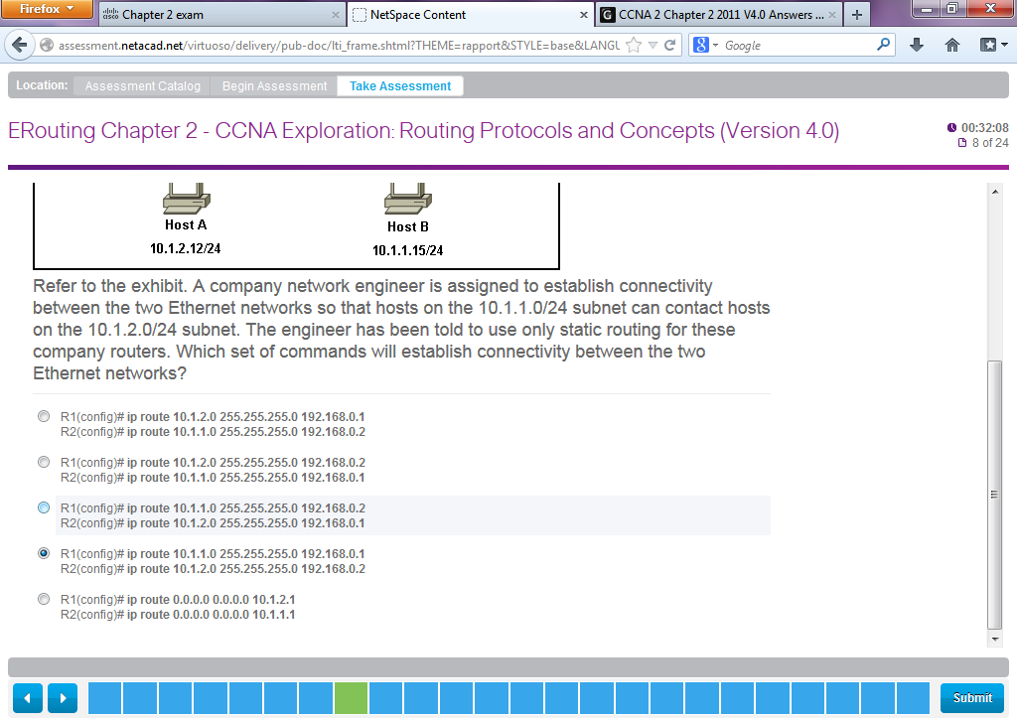

Got it wrong – correct answer

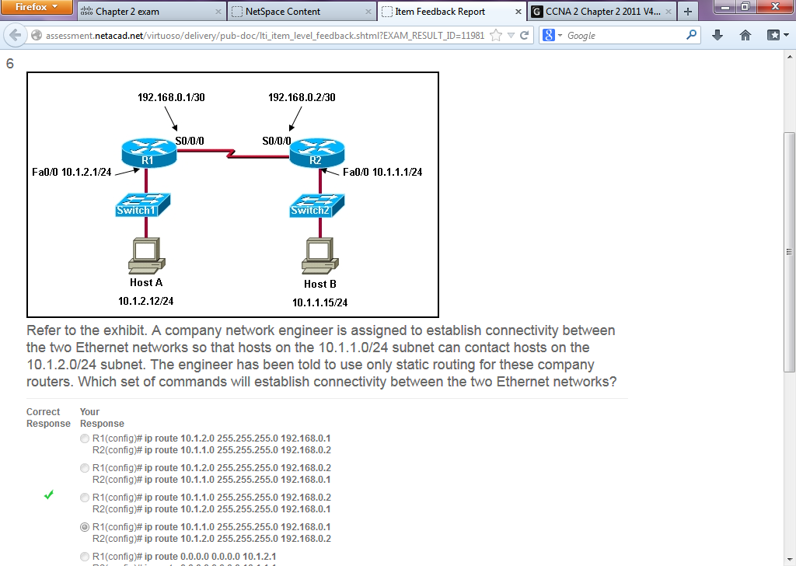

This item references content from the following areas:

CCNA Exploration: Routing Protocols and Concepts

* 2.4.2 Configuring Static Routes

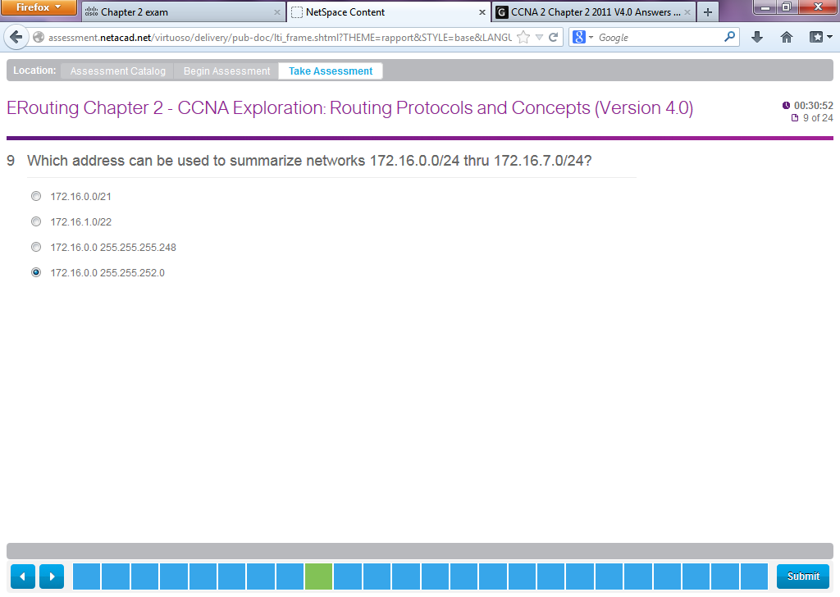

**2**. **What address can be used to summarize networks 172.16.1.0/24, 172.16.2.0/24, 172.16.3.0/24, and 172.16.4.0/24?**  
172.16.0.0/21  
172.16.1.0/22  
172.16.0.0 255.255.255.248  
172.16.0.0 255.255.252.0

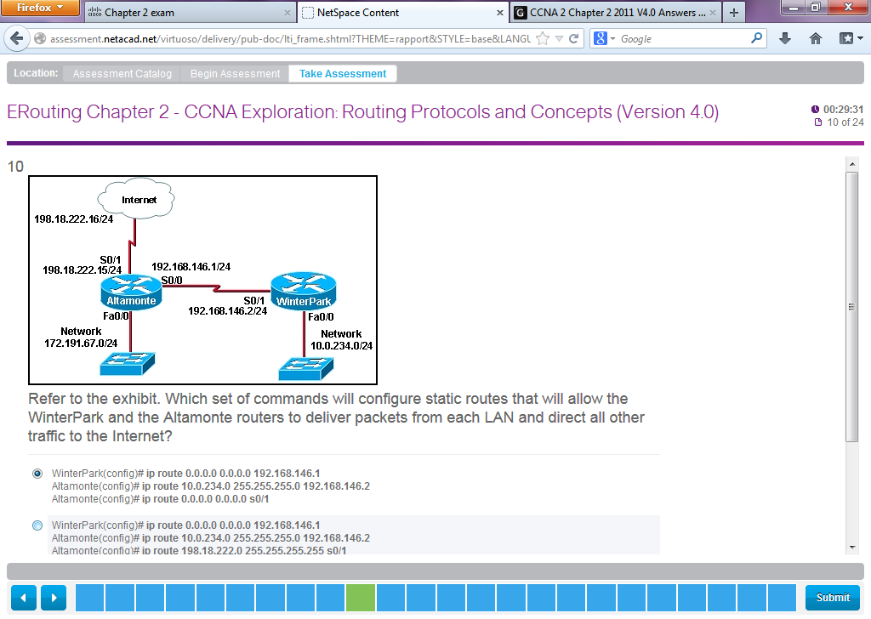

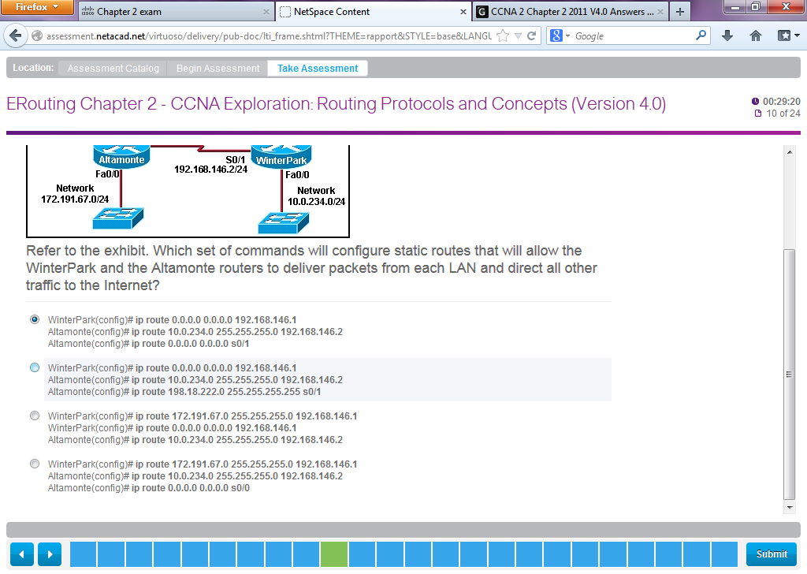

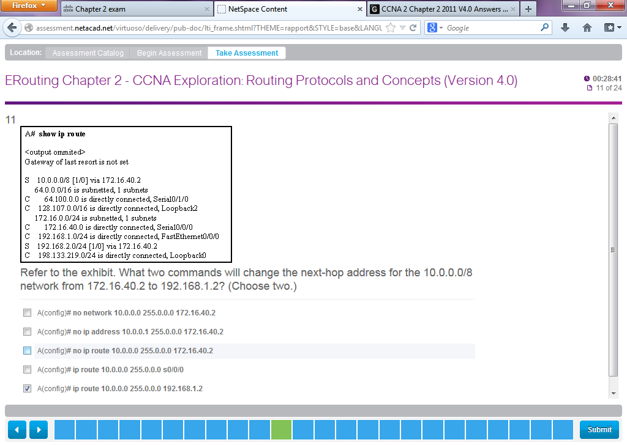

Read question!

**Refer to the exhibit. What two commands will change the next-hop address for the 10.0.0.0/8 network from 172.16.40.2 to 192.168.1.2? (Choose two.)**  
A(config)# no network 10.0.0.0 255.0.0.0 172.16.40.2  
A(config)# no ip address 10.0.0.1 255.0.0.0 172.16.40.2  
A(config)# no ip route 10.0.0.0 255.0.0.0 172.16.40.2  
A(config)# ip route 10.0.0.0 255.0.0.0 s0/0/0  
A(config)# ip route 10.0.0.0 255.0.0.0 192.168.1.2

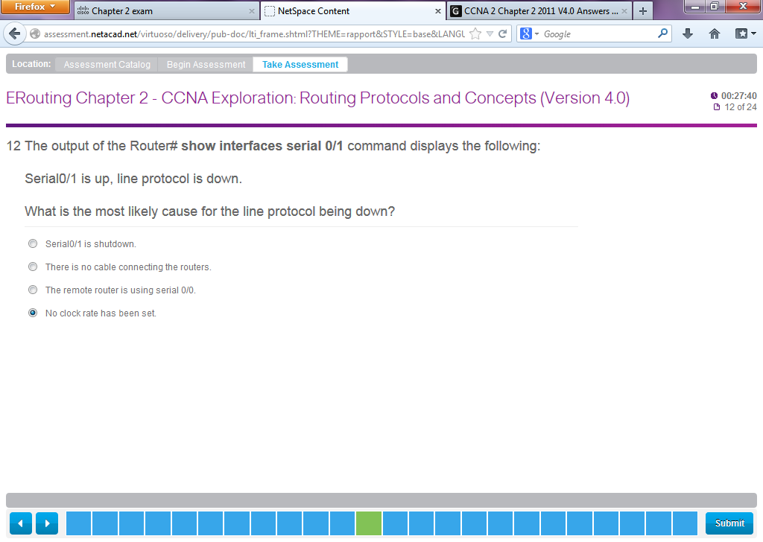

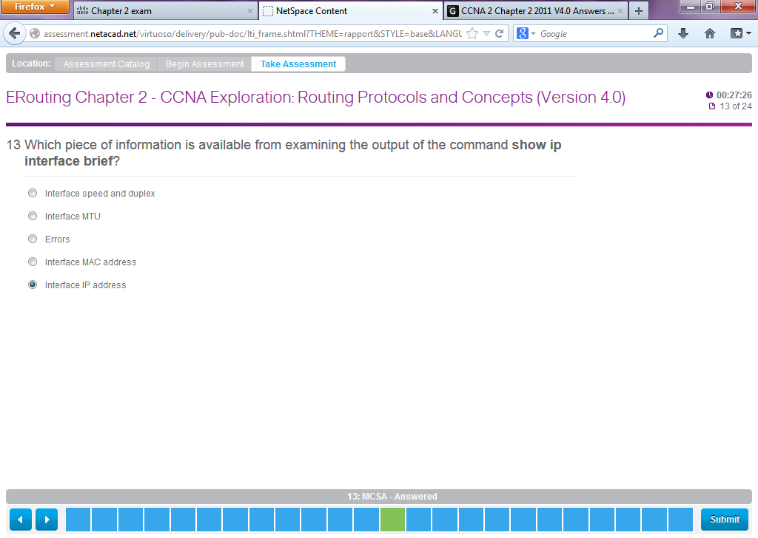

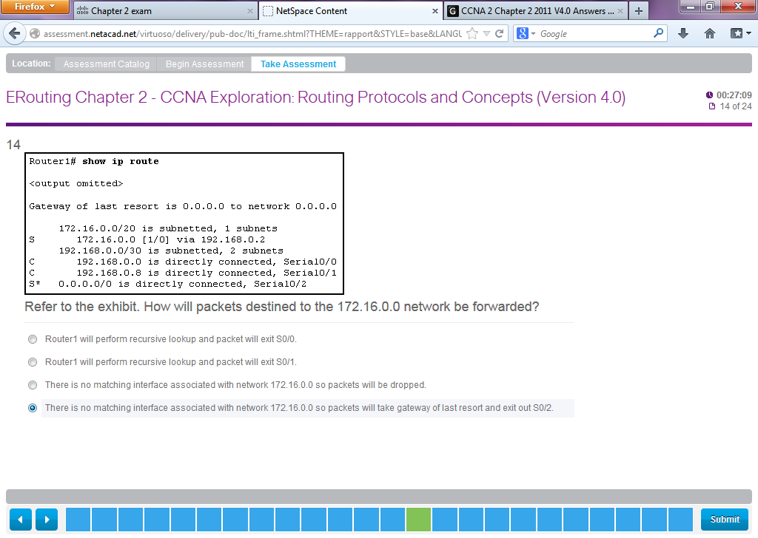

**Refer to the exhibit. How will packets destined to the 172.16.0.0 network be forwarded?**  
Router1 will perform recursive lookup and packet will exit S0/0.  
Router1 will perform recursive lookup and packet will exit S0/1.  
There is no matching interface associated with network 172.16.0.0 so packets will be dropped.  
There is no matching interface associated with network 172.16.0.0 so packets will take gateway of last resort and exit out S0/2.

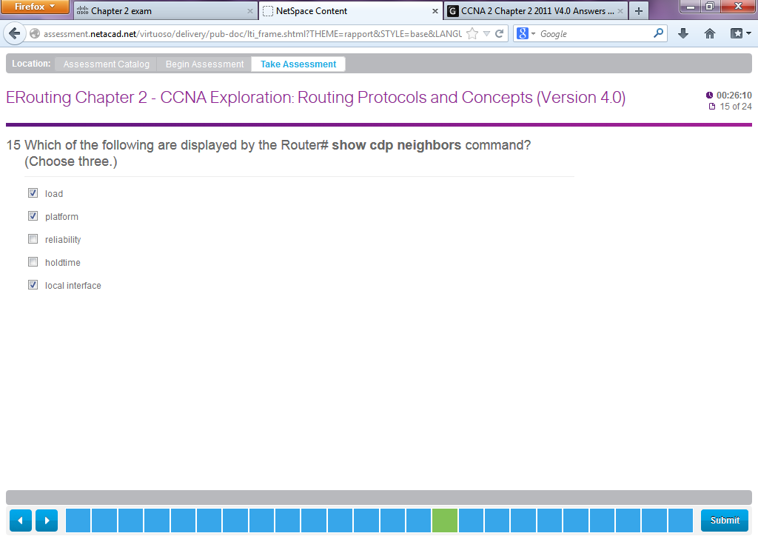

**11**. **Which of the following are displayed by the Router# show cdp neighbors command? (Choose three.)**  
load  
platform  
reliability  
holdtime  
local interface

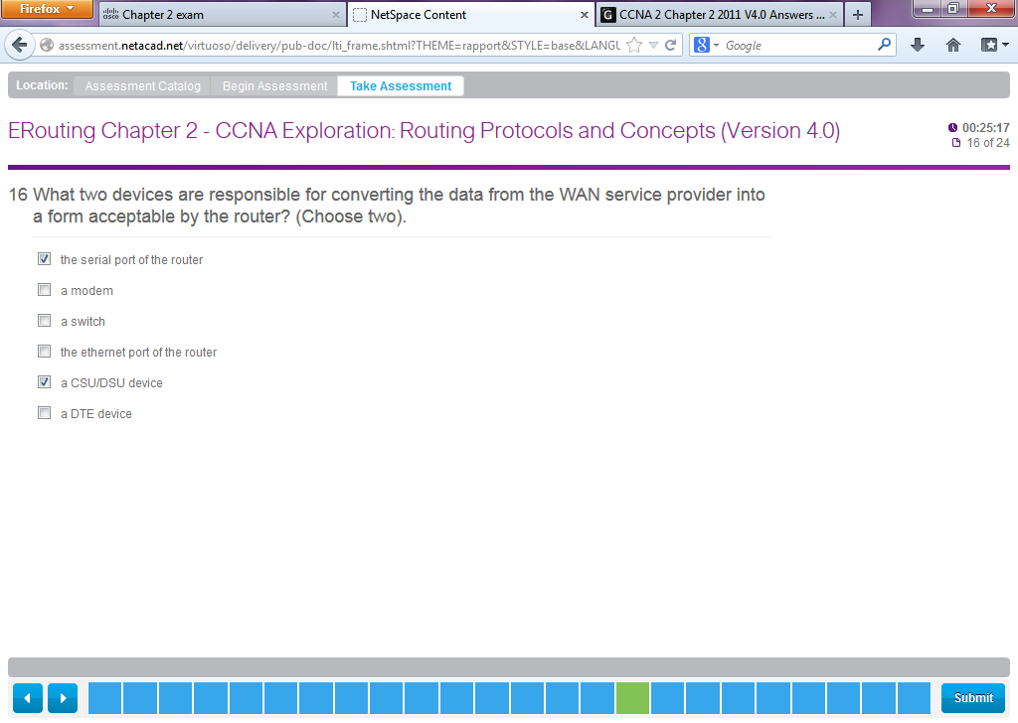

**19**. **What two devices are responsible for converting the data from the WAN service provider into a form acceptable by the router? (Choose two).**  
the serial port of the router  
a modem  
a switch  
the ethernet port of the router  
a CSU/DSU device  
a DTE device

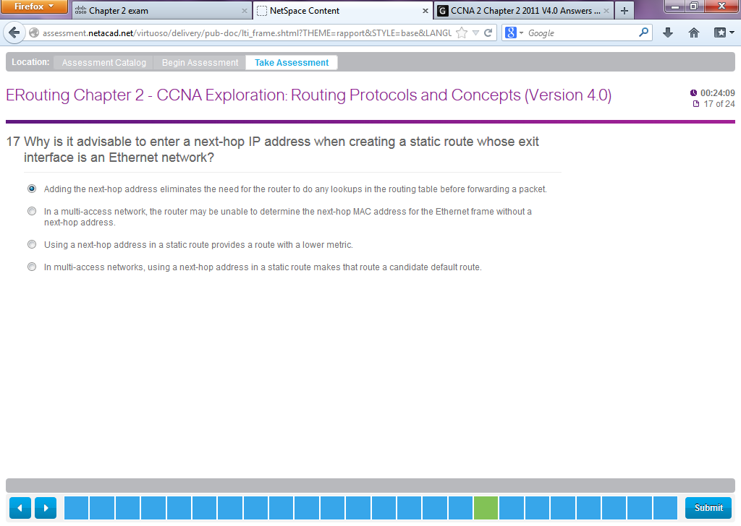

**16**. **Why is it advisable to enter a next-hop IP address when creating a static route whose exit interface is an Ethernet network?**  
Adding the next-hop address eliminates the need for the router to do any lookups in the routing table before forwarding a packet.  
In a multi-access network, the router cannot determine the next-hop MAC address for the Ethernet frame without a next-hop address.  
Using a next-hop address in a static route provides a route with a lower metric.  
In multi-access networks, using a next-hop address in a static route makes that route a candidate default route.

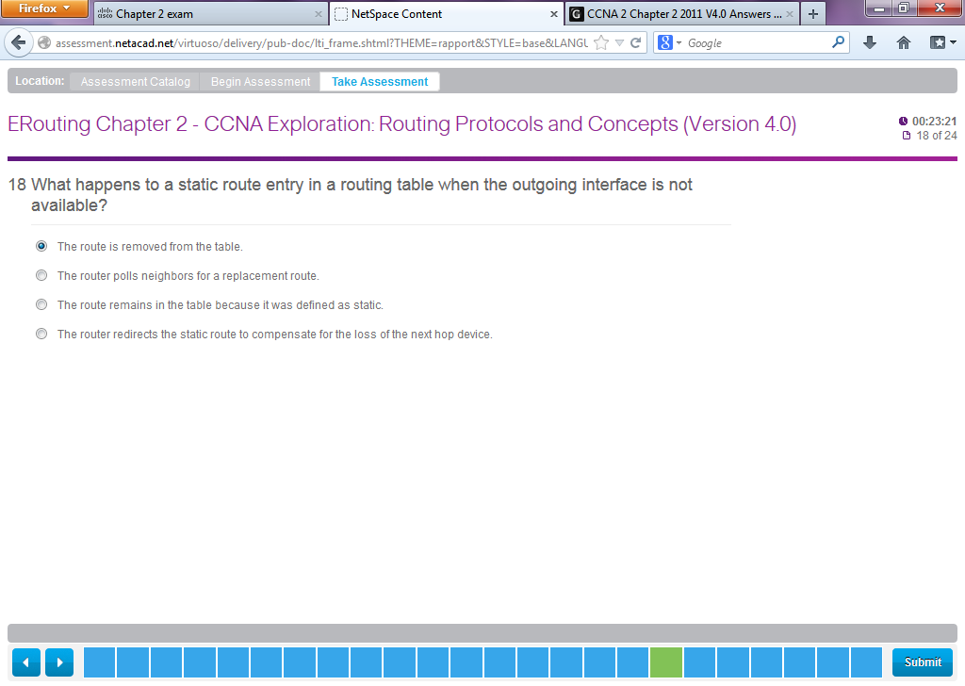

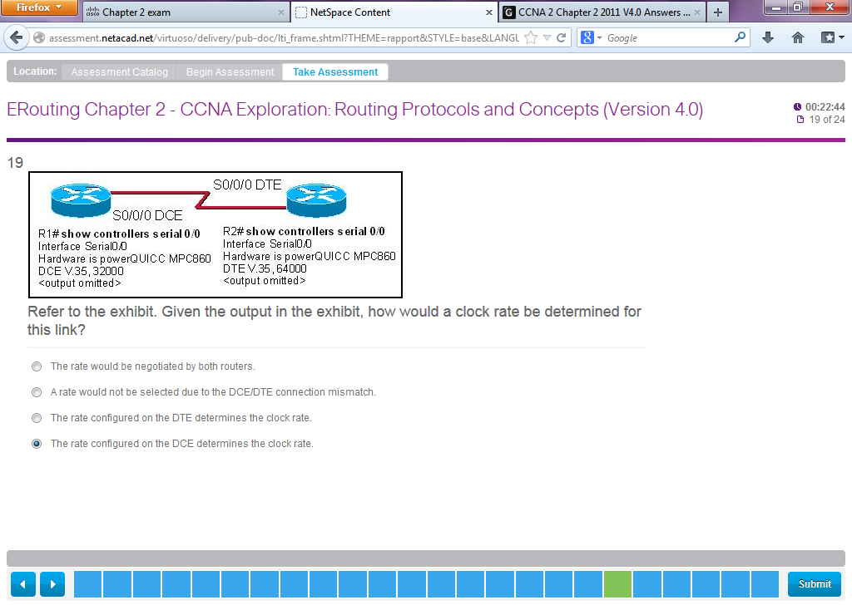

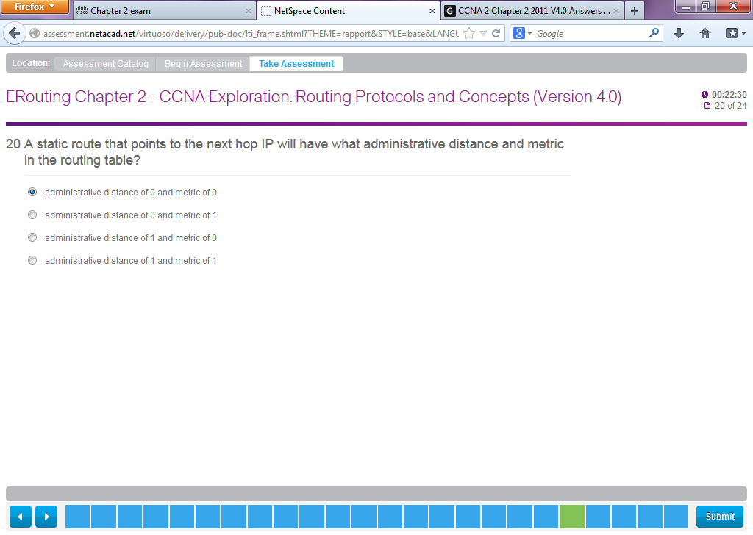

1. **A static route that points to the next hop IP will have what administrative distance and metric in the routing table?**  
   administrative distance of 0 and metric of 0  
   administrative distance of 0 and metric of 1  
   administrative distance of 1 and metric of 0  
   administrative distance of 1 and metric of 1

|  |  |  |
| --- | --- | --- |
|  | |  | | --- | | This item references content from the following areas:  CCNA Exploration: Routing Protocols and Concepts   * 2.4.2 Configuring Static Routes | |

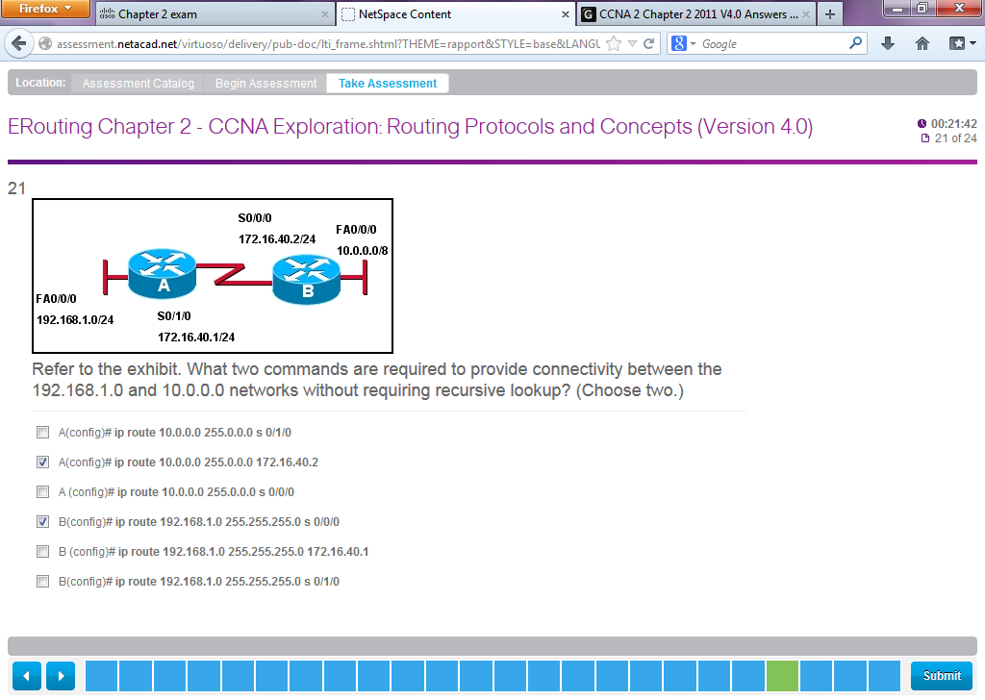

**Refer to the exhibit. What two commands are required to provide connectivity between the 192.168.1.0 and 10.0.0.0 networks without requiring recursive lookup? (Choose two.)**  
A(config)# ip route 10.0.0.0 255.0.0.0 s 0/1/0  
A(config)# ip route 10.0.0.0 255.0.0.0 172.16.40.2  
A (config)# ip route 10.0.0.0 255.0.0.0 s 0/0/0  
B(config)# ip route 192.168.1.0 255.255.255.0 s 0/0/0  
B (config)# ip route 192.168.1.0 255.255.255.0 172.16.40.1  
B(config)# ip route 192.168.1.0 255.255.255.0 s 0/1/0